T.kays Website Sitemap
- Home
- About T.kays
At T.kays Agrocosmetics, we believe healthy skin is more than a beauty goal. It is a form of confidence, self worth, and wellness. Born from a passion for holistic care and inspired by traditional African ingredients, T.kays was created to serve skin that has too often been overlooked, especially melanin rich skin that deserves targeted, effective, and respectful care.
Our products are carefully formulated to help treat concerns such as acne, hyperpigmentation, excess oil, uneven skin tone, dryness, and dull skin using potent herbal, natural, and skin loving ingredients. We do not believe in harsh shortcuts or unrealistic beauty standards. We believe in visible results, ingredient transparency, and skincare that supports you from the inside out.
T.kays is for the women, men and families who want more than a product on a shelf. It is for people who want to feel seen, understood, and empowered every time they look in the mirror. Every formula, every message, and every experience is built around one mission: to help you achieve healthy skin and the confidence that comes with it.
This is not just skincare. This is balanced wellness, rooted in culture, powered by nature, and made for your glow.
Shop T.kays today and give your skin the potent, intentional care it truly deserves.

I. Our Story

T.kays Agrocosmetics began with a simple but powerful belief: everyone deserves to feel confident in their skin.
Founded in 2018 by Tijesunimi Olakojo, T.kays was born out of a passion for beauty, wellness, and the desire to create something more meaningful for people whose skin needs are too often overlooked. What started as an extension of T.kays Collection evolved into a purposeful skincare brand rooted in care, culture, and visible results.
Inspired by traditional African ingredients and holistic wellness practices, T.kays was created to offer potent skincare solutions for real concerns such as acne, hyperpigmentation, excess oil, dryness, uneven skin tone, and dull skin, especially for melanin rich skin. From the very beginning, the mission has never been just to sell products. It has been to restore confidence, promote self worth, and help people feel seen, represented, and cared for.
At T.kays, we understand that skincare is personal. It is emotional. It is connected to how you feel about yourself when you wake up in the morning and when you step out into the world. That is why every product we create is made with intention using herbal, natural, and skin loving ingredients chosen for their effectiveness and their connection to African tradition.
But our story goes beyond formulations. T.kays is also about education, empowerment, and community. Through our content, tutorials, and training, we share knowledge that helps people make better skincare decisions and embrace healthier routines. We are committed to challenging unrealistic beauty standards and replacing them with something more honest, inclusive, and empowering.
Today, T.kays Agrocosmetics stands for balanced wellness. We are here for women, men, and families who want skincare that works and a brand that understands them.
This is our story. A story of nature, culture, healing, and glow.
And we are only just getting started.
Join the T.kays journey and discover skincare rooted in purpose, made for real skin, and created for lasting confidence.

II. Vision and Mission

Vision
To become a trusted global skincare brand known for delivering effective, culturally rooted, and holistic skincare solutions that empower women, men, and families to feel confident, healthy, and seen in their skin.

Mission
To unveil the beauty of black people through potent vegan, herbal, organic and naturally formulated products that improve, maintain, treat, repair and transform the skin and mental wellbeing by challenging conventional beauty norms and redefining beauty standards.

III.
Brand Values: Holistic Skincare, D.IC.E, V.H.O.N, Mental Wellness, Product potency
Acronyms:
VHON: Vegan, Herbal, Organic and Natural
DICE: Diversity, Inclusivity, Community and Equality
Holistic Skincare: Improve, Maintain, Transform, Treat, and Repair
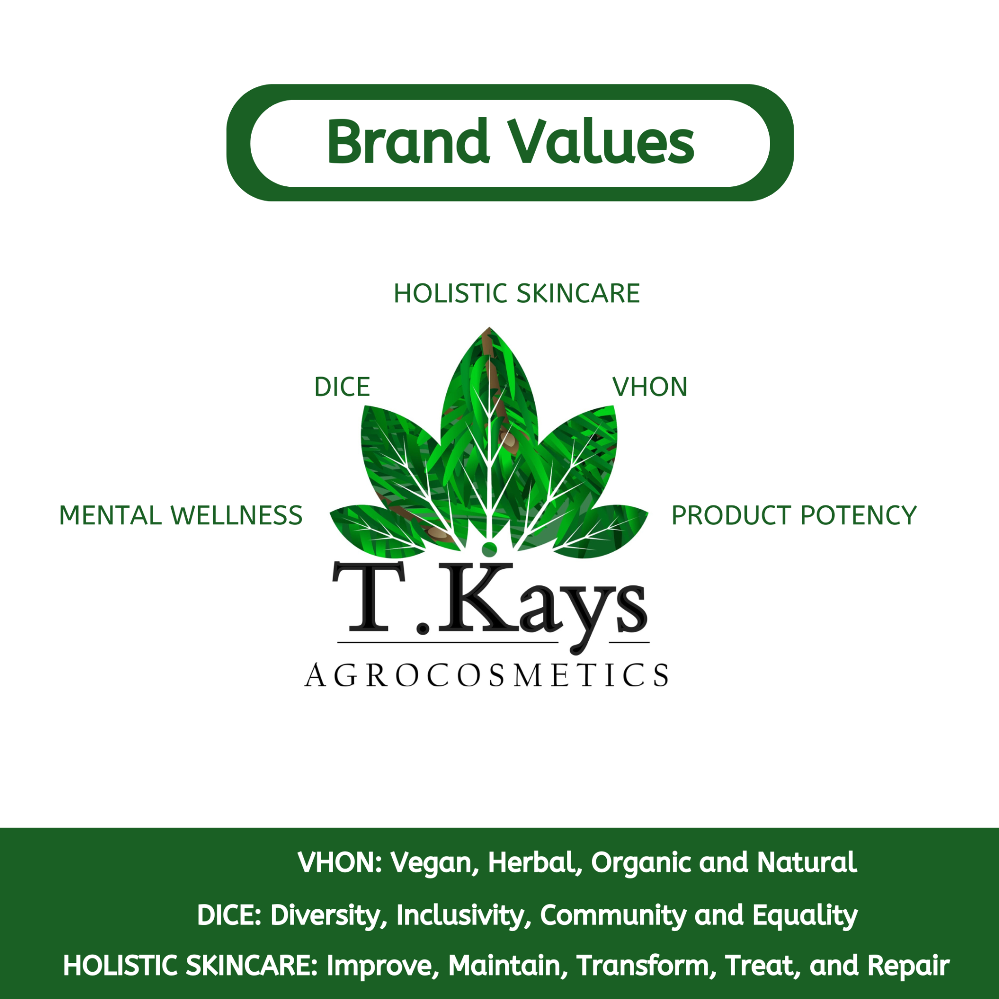

Iv. Slogan: Balanced Wellness
At T.kays Agrocosmetics, Balanced Wellness is at the heart of everything we do. For us, skincare is not only about how your skin looks, but also about how you feel in it.
We understand that skin concerns such as acne, hyperpigmentation, excess oil, dryness, and uneven skin tone can affect confidence and self esteem. That is why our approach goes beyond surface level beauty. We create skincare that supports healthy skin while also encouraging self care, confidence, and a more positive relationship with your natural appearance.
Balanced Wellness means choosing care that is intentional, effective, and rooted in respect for your skin. It means embracing ingredients inspired by African tradition, making informed skincare choices, and giving yourself the grace to heal, grow, and glow.
Through our products, education, and brand message, we are committed to challenging unrealistic beauty standards and replacing them with a healthier, more empowering idea of beauty, one that starts from within.
Because when your skin feels cared for, you feel more like yourself.
Balanced Wellness is not just our slogan. It is our promise.

- Shop
All Products
Best sellers
Face Care
Body Care
Black Soap
Bundles
New Arrivals
- Shop by Skin Concern
Acne
Hyperpigmentation
Excess Oil
Dry Skin
Uneven Skin Tone
Sensitive Skin
Repair and restoration
5. Hair care

6. Ingredients
Traditional African Ingredients
Natural Ingredients
Organic Ingredients
Herbal Ingredients
Vegan Ingredients
7. Results
I. Before and After
ii. Reviews and Testimonials

8. Balanced Wellness Hub
i. Blog
ii. Skincare Tips
iii. Mental Wellness

9. Self Care Guides
10. Training Academy
Workshops
Online Classes
YouTube Tutorials
11. Community
Influencer Content
Customer Stories
Referral Program
12. Contact
13. FAQ
14. Policies

Homepage Wireframe Structure
- Top Bar
WhatsApp contact, free delivery notice, discount code
- Header
Logo, menu, search, account, cart
- Hero Section
Strong brand message
Example:
Potent African skincare for healthy glowing skin
Button 1: Shop Now
Button 2: Explore Skin Concerns
- USP Section
Natural
Herbal
Effective
Inclusive
Sustainable
- Shop by Skin Concern
Acne
Hyperpigmentation
Excess oil
Dry skin
Uneven tone
- Best Sellers
Featured products like Black Soap, Acne Cream, Body Butter
- Why T.kays
Traditional African ingredients
Visible results
Mental wellness message
Safe and transparent skincare
- Before and After Section
Real customer transformations
- Ingredient Transparency Section
Show key ingredients and benefits
- Customer Reviews
Testimonials and star ratings
- Balanced Wellness Section
Short blog, self care, confidence messages
- Community Section
UGC, TikTok or Instagram content, referral invitation
- Newsletter Signup
Offer discount or skincare guide
- Footer
Contact, policies, social media, FAQ, academy links

Practical website folder template

tkays_website/
│
├── home/
├── about_us/
├── shop/
│ ├── all_products/
│ ├── acne_care/
│ ├── hyperpigmentation_care/
│ ├── oily_skin_care/
│ ├── dry_skin_care/
│ ├── sensitive_skin_care/
│ ├── black_soap_collection/
│ ├── body_care/
│ ├── face_care/
│ ├── bundles/
│ └── new_arrivals/
│
├── ingredients/
│ ├── traditional_african_ingredients/
│ ├── natural_ingredients/
│ ├── organic_ingredients/
│ ├── herbal_ingredients/
│ └── vegan_ingredients/
│
├── skin_concerns/
│ ├── acne/
│ ├── hyperpigmentation/
│ ├── blackheads/
│ ├── excess_oil/
│ ├── uneven_skin_tone/
│ └── dryness/
│
├── results/
│ ├── before_and_after/
│ ├── testimonials/
│ └── reviews/
│
├── balanced_wellness/
│ ├── blog/
│ ├── skincare_tips/
│ ├── mental_wellness/
│ └── self_care_guides/
│
├── training_academy/
│ ├── workshops/
│ ├── online_courses/
│ └── youtube_tutorials/
│
├── community/
│ ├── influencer_content/
│ ├── user_generated_content/
│ └── referral_program/
│
├── contact/
├── faq/
├── policies/
│ ├── shipping_policy/
│ ├── return_policy/
│ ├── privacy_policy/
│ └── terms_and_conditions/
│
├── assets/
│ ├── images/
│ ├── videos/
│ ├── icons/
│ └── brand_files/
│
└── admin/
├── orders/
├── customers/
├── inventory/
└── analytics/

Best folder sections for the front end
- Shop for product browsing
- Ingredients for transparency and trust
- Skin Concerns for targeted customer journeys
- Results for proof and credibility
- Balanced Wellness for brand storytelling
- Community for advocacy and engagement

If you want a simpler website menu version
You can reduce it to:
Home | About | Shop | Ingredients | Skin Concerns | Results | Balanced Wellness | Training | Community | Contact

